Session 2
Q1. Install GCC on your computer and verify the installation by running gcc --version in your terminal or command prompt.
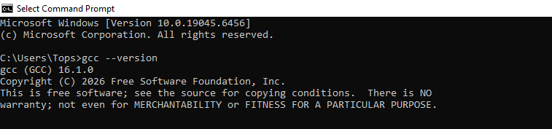
Ans:

Q2. Open VS Code or DevC++ and create a new file named hello.c. Write a C program that prints 'Hello, Instagram World!' to the console.
Ans: task2.cpp

Q3. Identify and label the header, main function, and return statement in your hello.c program using comments.
Ans: task3.cpp

Q4. Compile your hello.c file using the GCC command line (gcc hello.c -o hello) and run the output file to display the message in your terminal.
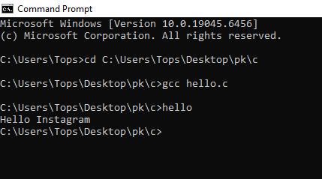
Ans:

